Amdocs: Work Hours (WH) Overview

All Amdocs employees and contractors record their hours worked within the Amdocs Work Hours (“WH”) timecard system of record which is based on tenth increments (.1, .3, etc) and will port into IQN accordingly.

Using this system, you are able to record your:

• Daily hours present/worked on the project

**As a contractor, it is critical that you follow up diligently with your Amdocs manager each week to ensure that they have approved** **your time for the week in the WH system!!!**

• Time spent on projects and tasks

• Absence hours (Amdocs Employees only)

• Vacation time (Enter ZEROs using the Reporting Code that you were given)

Using this System, the company is able to:

• Track and maintain integrity of customer invoices

• Manage project work plans and progress

• Analyze presence and absence hours

For **contractors**, your pay is based off of the hours entered and approved in the WH system. You will need to enter your weekly timecard **by COB Fridays**. Weekending is SATURDAYS.

**DO NOT ENTER PRIOR TO THE END OF THE WEEK!** Amdocs WH system considers the week starting on Sunday & ending on Saturday. Any approvals that are done before the week ends (for that week itself) is considered as invalid by WH system & the data isn’t sent to IQN system on the Wednesday morning timecard port. All approvals should happen in WH system only after the week ends. For example, report time by Friday EOD & your 1st and 2nd line managers can approve it on Monday.

**FOR EXAMPLE:** Timecards for Weekending Saturday, Oct 8, 2016, need to be entered by EOD Friday Oct 7th or Saturday Oct 8th and in STATUS B for manager approvals. This will allow time for the 1st and 2nd line managers to approve by COB Tuesdays of the following week. Once both managers approve and the timecard is in STATUS D by COB Tuesday, this will allow the timecard to port into IQN on Wednesday Morning.

All approved work hours are downloaded into an automated Vendor Management System called IQNavigator, which generates a statement for the individual vendors. Since the statements are generated directly from Work Hours, it is critical that every manager approve time each week by COB on Tuesdays for each contractor. If the time is not approved and in STATUS D, the system will calculate 0 hours worked, which can delay IQN invoicing and payments.

**Employees accessing the Amdocs network via RAS/VPN/LAN connection:**

• Open Internet Explorer

• Access the Amdocs Intranet portal page: **http://portal/Pages/homepage.aspx**

• Click on the Work Hours link

**Employees located at a customer site and accessing the amdocs network via the Amdocs WebGate site (Google Chrome DOES NOT work):**

**\*\*\*\*\*\*\* MGRS MUST REQUEST A SECURE ID FROM AMDOCS IT DEPT \*\*\*\*\*\*\*\***

• Open Internet Explorer (some Web Browsers ARE NOT Compatible-please be cognizant of that if you get a blank screen) and connect to the Amdocs WebGate page: **http://webgate.amdocs.com**

• Enter your Amdocs Digipass (Secure ID) token username and password

• Click on the WH Reporting system link

• Enter your Amdocs NT username, password, and domain

**COLOR SYSTEM on Weeks in WH:**

**GREEN:** Future timecards (**DO NOT ENTER and submit for approval!** They will not flow into IQN for processing/invoicing and a manual load will be required)

**BLACK:** Closed weeks (this means that if you do not enter them in time, anything that needs to happen to these weeks a time consuming WH Support ticket will need to be created to enter, change, push for approvals, etc. See more details and instructions below)

**BLUE:** Weeks are open for employee reporting but **DO NOT enter prior to the current Week End** (Saturday). Please **enter on Fridays at COB for the current week or the following Monday** on a Weekly basis.

**RED:** Current week

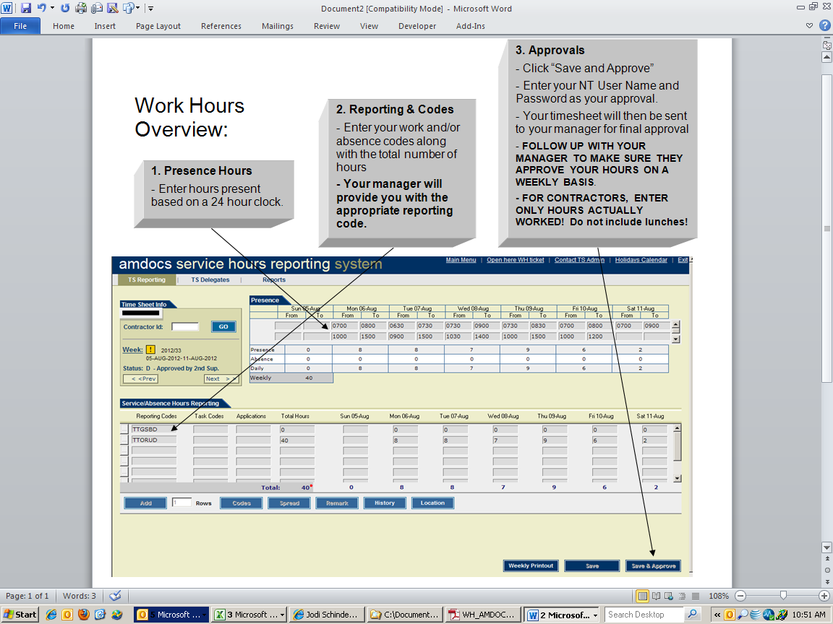

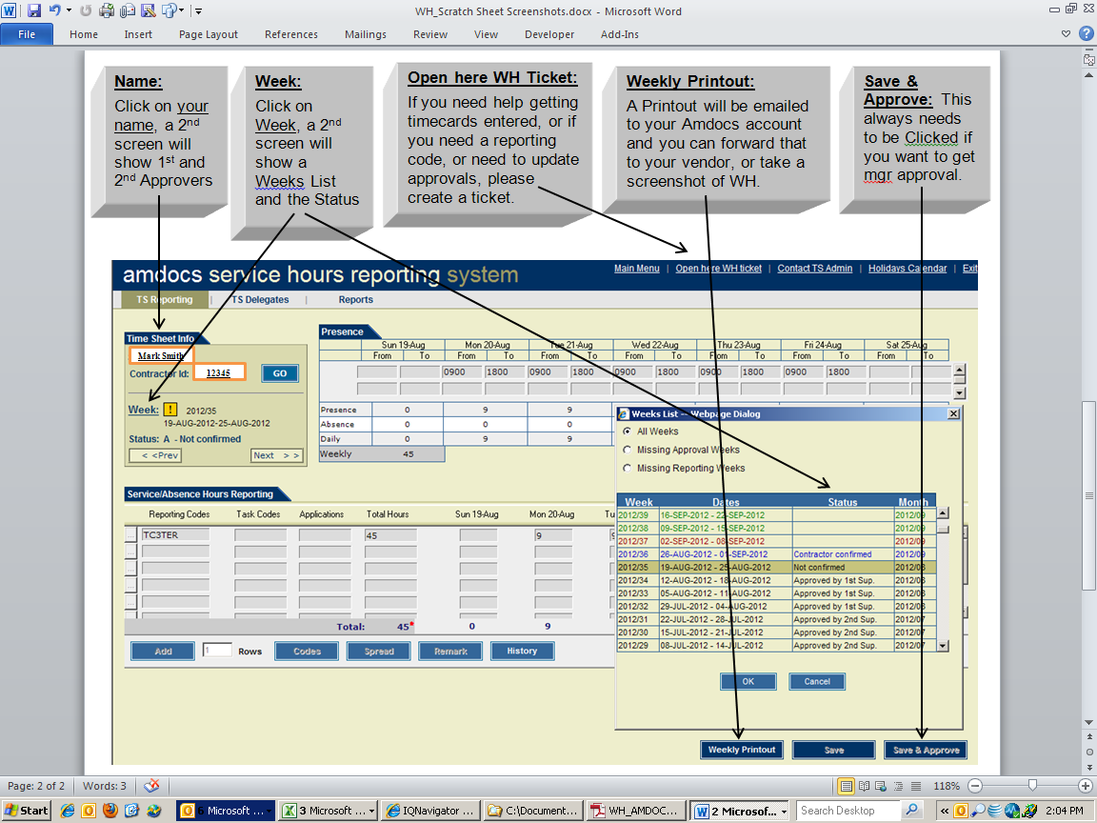

**STATUS EXPLANATION:**

Once "Saved & Approved" by contractor, there are FOUR steps that the WH timecards go through (Status A-D):

* **Status A: NOT CONFIRMED**: Contractor has only SAVED the timecard and can make changes before sending it for approval.
* **Status B: CONTRACTOR CONFIRMED:** The hours are correct and ready for 1st and 2nd Supervisor Approval.
* **Status C: APPROVED by 1st Sup**
* **Status D: APPROVED by 2nd Sup**

Once in Status D, the timecard will migrate into IQNavigator WEEKLY on Wed Mornings. To find out the Supervisors, click on the WEEKLY PRINTOUT and the timecard will be sent to resource via email

**VENDOR NEEDS TO KNOW THE TOTAL AMOUNT OF HOURS AND STATUS OF TIMESHEET IN WH**

**Please send details to the vendor so they can ensure hours are being entered and approved in STATUS D Weekly by COB Tuesdays-following the previous week.**

1. Screenshots of the WH timecards can be emailed to your employer
2. Or you may be able to generate your own report of the weekly hours by clicking on REPORTS in WH and see if that works
3. OR click on the WEEKLY PRINTOUT of a timecard which will send an email to your Amdocs email which you can forward to your employer
4. OR History gives the hours for that timecard and you can screenshot and send to your employer

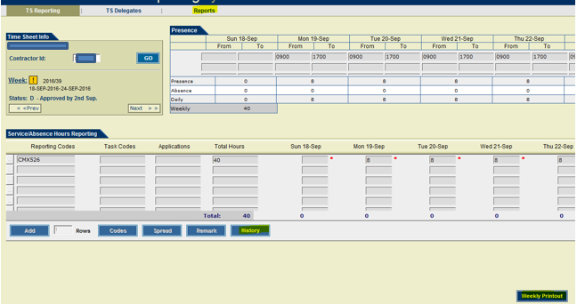

**NO WEEKS GO UN-ENTERED/UN-ACCOUNTED! If you have taken a WEEK vacation/holiday/sick, that week needs to be entered as ZERO’s on your Reporting Code that was provided to you and Submit that for manager approvals.**

**IF YOU FORGOT TO ENTER A WEEK/S in the PAST**

**Weeks will be CLOSED and a ticket will need to be created in WH! To avoid this cumbersome task, PLEASE SET UP A REMINDER IN OUTLOOK ON FRIDAYS TO ENTER YOUR TIMECARDS IN WH.**

**Reasons a Ticket in WH will need to be created:**

1. **Contractor took on Vacation and forgot to enter ZEROs on the Reporting Code that they are using and they need to submit to manager for approval. No weeks go un-entered/unaccounted.**
2. **Contractor forgot to enter weeks in the PAST.**
3. **Timecard remains in STATUS A because contractor has not SAVE & APPROVED an old timecard that is Closed.**

In the upper Right hand corner of Work Hours, they will click on “Open here WH Ticket”

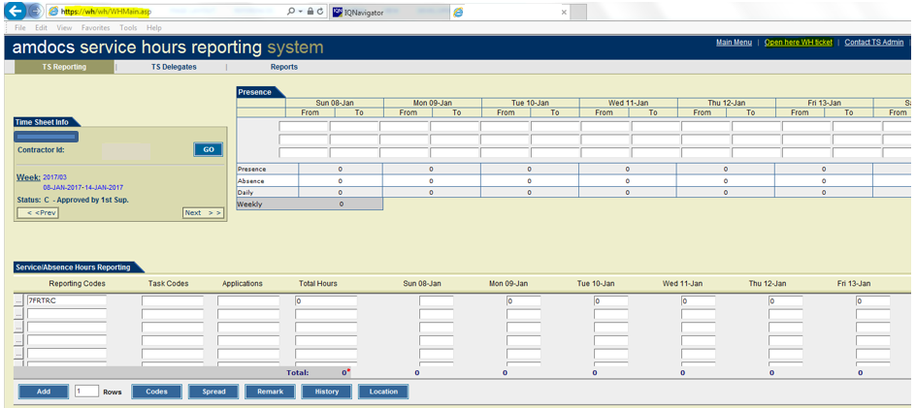

Select MISSING TS/APP 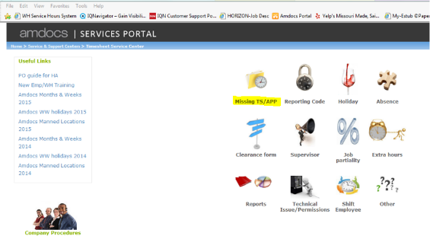

Select “Missing TS” and Click CONTINUE 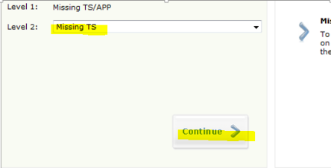

Below is an EXAMPLE to follow! Fill in the fields accordingly (below is an EXAMPLE of entering so he just needs to fill in the blanks to accommodate his request)

Everyone will need to say this statement below in the Description! If they do not, the timecard will sit in STATUS A and the manager will never see it to approve:

**“Week/s is closed. I can’t enter my timecard/s. Please see below and enter on my behalf.**

**AND PUSH TO STATUS B FOR MANAGER APPROVAL. IT WILL NOT ALLOW ME TO APPROVE DUE TO WEEK BEING CLOSED.”**

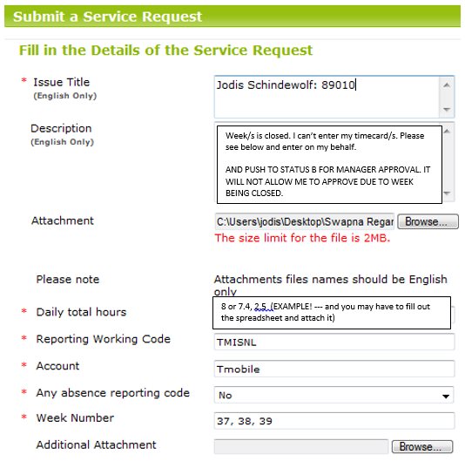

**Hours cannot be invoiced through IQN without timecards entered and approved by the managers in Work Hours. Work Hours is the timecard system of record and need to be entered and approved to STATUS D for invoicing in IQN.**